CYBER SECURITY:
MAJOR PROJECT

Design and Implementation of a Centralized Log Monitoring and Threat Detection System using ELK Stack

Project Report
Student Name: NAVISHTHA TIWARI
Course: BTECH (CYBERSECURITY)

Introduction
Modern enterprise environments generate a large volume of logs from operating systems, applications, authentication services, network devices, and other infrastructure. These logs contain important security information such as successful and failed login attempts, user activities, system events, and indicators of suspicious behavior. When logs are stored and monitored separately on different systems, it becomes difficult for security analysts to identify patterns, investigate incidents, and detect unauthorized access or malicious activities in a timely manner.
This project focuses on designing and implementing a Centralized Log Monitoring and Threat Detection System using the ELK Stack, which consists of Elasticsearch, Logstash, and Kibana. The main purpose of the system is to collect logs from multiple endpoints and bring them into a centralized environment where they can be processed, stored, searched, and analyzed. The project uses Windows and Linux systems as endpoints, with Winlogbeat and Filebeat used as log collection agents. The collected logs can then be viewed and analyzed through Kibana using queries and visualizations.
The project simulates a small Security Operations Center (SOC) environment in which security-related events can be monitored from a central location. Instead of checking individual machines separately, a security analyst can use Kibana to search and analyze events generated by different endpoints. This makes it easier to identify suspicious activities, investigate authentication events, and understand the overall security status of the monitored systems.
The project also focuses on practical cybersecurity use-cases such as Windows failed login detection, suspicious successful logins, Linux SSH login monitoring, and File Integrity Monitoring. Windows authentication events, including Event ID 4624 for successful logins and Event ID 4625 for failed logins, can be analyzed to identify unusual or potentially malicious login activity. Linux authentication and system logs can similarly be used to monitor SSH access and changes to important files.
Through this project, practical knowledge of centralized logging, SIEM concepts, ELK Stack components, log collection, Kibana Discover, KQL-based analysis, and security monitoring is developed. The project demonstrates how logs from different systems can be brought together into a centralized platform and analyzed to support threat detection and incident investigation. It also provides practical exposure to the type of monitoring and analysis activities performed by SOC analysts in real-world cybersecurity environments.

2. Objectives

The main objectives of this project are:
- To understand the concept of centralized logging and SIEM and learn how security-related logs from different systems can be monitored from a single centralized platform.
- To deploy and configure the ELK Stack, including Elasticsearch, Logstash, and Kibana, for centralized log storage, processing, monitoring, and visualization.
- To collect logs from Windows and Linux endpoints using Beats, particularly Winlogbeat for Windows Event Logs and Filebeat for Linux authentication and system logs.
- To analyze and query collected logs for security monitoring using Kibana Discover and Kibana Query Language (KQL).
- To identify suspicious and security-relevant activities, such as failed login attempts, successful logins following multiple failures, unauthorized SSH access, and changes to sensitive files.
- To implement security monitoring use-cases including Windows Failed Login Detection, Suspicious Successful Login Detection, Linux SSH Login Monitoring, and File Integrity Monitoring.
- To create dashboards and alerts for threat detection so that important security events can be visualized and monitored more effectively.
- To gain practical exposure to SOC analyst workflows, including centralized log collection, event investigation, security monitoring, and basic threat-detection techniques.

3. System Requirements
The project brief specifies three virtual machines: Ubuntu Server as the ELK server, Windows 7/10 as the Windows endpoint, and Linux/Ubuntu/Kali as the Linux endpoint or attacker environment.

4. Project Architecture
The intended architecture is Windows 10 -> Winlogbeat -> ELK Server -> Elasticsearch -> Kibana, and Kali Linux -> Filebeat -> ELK Server -> Elasticsearch -> Kibana. Kibana is used for visualization, querying and analysis.

5. Technologies and Components
The project uses different technologies and components to collect, process, store, analyze, and visualize security logs from Windows and Linux endpoints.

1. ELK Stack
The ELK Stack is the core technology used in this project. It consists of Elasticsearch, Logstash, and Kibana.

a) Elasticsearch
Elasticsearch is used for storing, indexing, and searching collected log data. It allows security events to be searched quickly based on different fields such as timestamp, hostname, event ID, and severity.

b) Logstash
Logstash is used for processing and transforming log data before it is stored in Elasticsearch. It receives logs from the endpoints, processes them, and forwards the data to Elasticsearch.

c) Kibana
Kibana provides the visual interface for monitoring and analyzing the collected logs. It is used to:
- View logs using Discover
- Perform searches using KQL
- Analyze security events
- Create dashboards and visualizations
- Support security monitoring and alerting

2. Winlogbeat
Winlogbeat is a lightweight data shipper used on the Windows endpoint. It collects Windows Event Logs and forwards them to the ELK environment.
The project uses it to collect:
- Security logs
- System logs
- Application logs
It is particularly useful for analyzing Windows authentication events such as Event ID 4624 (successful login) and Event ID 4625 (failed login).

3. Filebeat
Filebeat is a lightweight log shipper designed for Linux systems. It is intended to collect Linux authentication and system logs and forward them to the ELK server.
The project specifies collection of:
- auth.log – authentication-related events
- syslog – general system events

4. Kibana Query Language (KQL)
KQL is used in Kibana to search and filter the collected log data. It helps identify specific security events from a large number of logs.
Examples used in the project include:
event.code:4624
for successful Windows logins, and
event.code:4625
for failed Windows login attempts.

5. VirtualBox / VMware
Virtualization software such as VirtualBox or VMware is used to create and run the virtual machines required for the project. The project environment consists of an Ubuntu ELK server, a Windows endpoint, and a Linux/Kali endpoint.

6. Windows and Linux Endpoints
The project uses both Windows and Linux systems as monitored endpoints. This allows the centralized monitoring system to demonstrate log collection and security analysis across different operating systems.

7. Security Monitoring and Visualization
Kibana dashboards and visualizations are used to present security information in an understandable form. The project focuses on monitoring login attempts, security events, and suspicious activities to support threat detection and SOC-style analysis.

6. Implementation Methodology
The implementation of the project is carried out in different phases to establish a centralized log monitoring and threat detection environment using the ELK Stack. The methodology involves setting up the ELK server, configuring endpoint log collection, forwarding logs, analyzing events using Kibana and implementing security monitoring use-cases.

Phase 1: ELK Stack Installation and Configuration
The first phase involves setting up the central Ubuntu Server as the ELK server.
- Elasticsearch Installation
Elasticsearch is installed and configured on the Ubuntu server. It is responsible for storing, indexing, and searching the logs received from the endpoints.
- Logstash Installation
Logstash is installed to receive and process log data. It performs the required processing and forwards the logs to Elasticsearch.
- Kibana Installation
Kibana is installed as the visualization and monitoring interface. It provides the Discover feature for viewing logs and supports KQL-based searches and visualizations.
- ELK Service Verification
The ELK components are checked to ensure that they are running correctly and are ready to receive endpoint logs.

Phase 2: Endpoint Log Collection
After setting up the ELK server, the endpoint systems are configured to collect and forward logs.

Windows Endpoint
The Windows 10 machine is configured with Winlogbeat.
Winlogbeat collects:
- Windows Security Logs
- Windows System Logs
- Windows Application Logs
The collected Windows Event Logs are forwarded to the ELK server for centralized analysis.

Linux Endpoint
The Linux/Kali machine is intended to be configured with Filebeat.
Filebeat is used to collect:
- auth.log for authentication-related events
- syslog for general system events
These logs are then forwarded to the central ELK server.

Phase 3: Log Flow Analysis
Once logs reach the ELK environment, they are analyzed using Kibana.
The following important log fields are examined:
- Timestamp – identifies when an event occurred.
- Hostname – identifies the system that generated the event.
- Event ID – identifies the type of Windows security event.
- Severity Level – helps determine the importance of an event.
Kibana Discover is used to view the collected events, while Kibana Query Language (KQL) is used to search and filter specific security events.
For example:
event.code:4624
is used to identify successful Windows login events, while:
event.code:4625
is used to identify failed Windows login attempts.

Phase 4: Security Use-Case Implementation
The collected logs are used to demonstrate different cybersecurity use-cases.

1. Windows Failed Login Detection
Event ID 4625 is analyzed to identify failed login attempts and possible brute-force activity.

2. Suspicious Successful Login
Event ID 4624 is analyzed to identify successful logins that may occur after multiple failed attempts, which could indicate a potentially compromised account.

3. Linux SSH Login Monitoring
Linux authentication logs are intended to be monitored for SSH login attempts and possible unauthorized access.

4. File Integrity Monitoring
Changes to sensitive files on Linux systems are intended to be tracked to identify unauthorized modifications.

Phase 5: Dashboard and Alerting
The final stage involves using Kibana to present security information through dashboards and visualizations. Login attempts, error events, and other security-related activities can be displayed in an easy-to-understand format.
Alerts can also be configured for suspicious activities such as multiple failed login attempts, unauthorized access patterns, and abnormal system activity.
This methodology provides a structured approach for collecting logs from different endpoints, centralizing them on the ELK server, analyzing them using KQL, and using the results for security monitoring and threat detection.

7. Log Collection and Analysis
Log collection and analysis is an important part of the centralized monitoring system. The main purpose of this phase is to collect security and system-related logs from different endpoints and make them available at a central location for analysis. In this project, Windows and Linux systems are considered as endpoints, while the Ubuntu server hosts the ELK Stack.

1. Windows Log Collection
The Windows endpoint uses Winlogbeat to collect Windows Event Logs. Winlogbeat is configured to collect important categories of Windows logs, including:
- Security Logs
- System Logs
- Application Logs
These logs contain information about user authentication, system activities, application events, and security-related activities. The collected logs are forwarded to the ELK server for centralized processing and analysis.

2. Linux Log Collection
The Linux endpoint uses Filebeat for collecting Linux system and authentication logs. The project specifies the collection of:
- auth.log – contains authentication-related activities such as login attempts and SSH-related events.
- syslog – contains general system and service-related events.
The collected Linux logs are intended to be forwarded to the central ELK server for analysis.

3. Log Processing and Storage
After collection, the logs are forwarded to the ELK environment. Logstash processes the incoming log data and prepares it for storage. Elasticsearch then stores and indexes the processed logs.
Indexing allows the collected information to be searched efficiently based on different fields and event attributes.

4. Log Analysis Using Kibana
Kibana is used as the main interface for viewing and analyzing the collected logs. The Discover section provides a detailed view of individual log events.
During the implementation, the winlogbeat-* data view was used to access Windows logs. Important fields examined during analysis include:
- Timestamp
- Hostname
- Event ID
- Severity level
- Username
- Logon information
- Authentication-related details

5. KQL-Based Analysis
Kibana Query Language (KQL) is used to search for specific events within the collected logs. For example, Windows successful login events can be searched using:
event.code:4624
Event ID 4624 represents a successful Windows logon and can be used to study normal authentication activity.
Failed login events can be searched using:
event.code:4625
Event ID 4625 represents a failed Windows logon and is important for identifying repeated authentication failures and possible brute-force activity.

6. Centralized Log Analysis
Centralizing logs makes it easier to compare events from different systems and identify suspicious patterns. Instead of examining each endpoint individually, the security analyst can use Kibana to search and analyze events from a central location.
The collected information can be used to investigate authentication activity, identify unusual login attempts, observe system events, and support the security use-cases defined in the project.
Overall, the log collection and analysis process provides the foundation for centralized security monitoring, event investigation, and threat detection using the ELK Stack.

8. Security Use-Cases
Use-Case 1: Windows Failed Login Detection — monitor multiple failed logins and analyze Event ID 4625 for possible brute-force activity.
Use-Case 2: Suspicious Successful Login — detect successful logins following multiple failures and identify possible compromised-account activity.
Use-Case 3: Linux SSH Login Monitoring — monitor SSH login attempts and detect unauthorized access.
Use-Case 4: File Integrity Monitoring — track changes to sensitive Linux files.

9. Kibana and KQL Analysis
KQL queries prepared for Windows authentication monitoring include:
event.code:4624
event.code:4625
event.code:(4624 or 4625)
Recommended dashboard visualizations are Successful Windows Logins, Failed Windows Logins, Windows Login Activity and Login Activity by User.

10. Results and Observations
The implementation of the centralized log monitoring system using the ELK Stack produced the following results and observations:

1. ELK Environment
The Ubuntu server was used as the central ELK server. The ELK environment provides a centralized platform for receiving, storing, searching, and analyzing security logs.

2. Windows Log Collection
The Windows endpoint was successfully configured with Winlogbeat for collecting Windows Event Logs. The collected logs were made available in Kibana through the winlogbeat-* data view.
This confirmed that Windows security events could be viewed and analyzed from the centralized Kibana interface.

3. Successful Login Detection
Event ID 4624 was successfully identified in Kibana. This event represents a successful Windows logon.
The event details provided useful information such as:
- Timestamp
- Username
- Workstation
- Event ID
- Logon information
- Audit status
This demonstrated that successful authentication activity could be monitored through the ELK environment.

4. Failed Login Detection
Event ID 4625 was used for analyzing failed Windows login attempts. Failed authentication events are important from a cybersecurity perspective because repeated failures may indicate password-guessing or brute-force activity.
The event data can be examined to identify details such as the target username, logon type, failure reason, and source information.

5. KQL-Based Analysis
Kibana Query Language (KQL) was successfully used to filter and search Windows security events. Queries such as:
event.code:4624
and
event.code:4625
allow the analyst to quickly locate successful and failed authentication events.

6. Centralized Monitoring
The project demonstrated the advantage of centralized monitoring because security events from the Windows endpoint could be examined from Kibana instead of manually checking the Windows machine.
This provides a more convenient approach for security monitoring and investigation.

7. Linux Endpoint Observation
Kali Linux was successfully connected to the project network and communication with the Ubuntu ELK server was tested. However, during implementation, the installation of Filebeat was blocked because Kali experienced network/DNS connectivity problems while accessing the package repository.
Therefore, the Linux Filebeat-based collection of auth.log and syslog, along with the Linux SSH and file-integrity use-cases, could not be fully demonstrated during the practical session.

8. Overall Observation
The implemented Windows log-collection and analysis pipeline demonstrated the basic working concept of a centralized SIEM-style monitoring system. Winlogbeat, Elasticsearch, Logstash, and Kibana can work together to collect and analyze Windows security events, while KQL provides an effective method for locating specific events.
The project also showed that reliable network connectivity between endpoints and the ELK server is essential for successful centralized log collection.

11. DASHBOARD AND ALERTING
The Kibana dashboard is an important component of the centralized log monitoring system. It provides a graphical representation of security events and makes it easier for a security analyst to monitor and investigate suspicious activities.

10.1 Kibana Dashboard
Kibana can be used to create a security monitoring dashboard using the logs collected from the endpoints. The dashboard provides a centralized view of authentication and system-related events.
The main visualizations included in the dashboard are:
- Successful Login Attempts – displays successful Windows login events using Event ID 4624.
- Failed Login Attempts – displays failed Windows login events using Event ID 4625.
- Login Activity – provides an overall view of successful and failed authentication events.
- Login Activity by User – helps identify which users are involved in authentication events.
- Error Events – helps in identifying security-related errors and abnormal activities.
- Source Information – can be used to observe the systems or source addresses associated with events.

10.2 KQL Queries Used
The following KQL queries can be used for dashboard analysis:
Successful Login:
event.code:4624
Failed Login:
event.code:4625
All Login Events:
event.code:(4624 or 4625)
These queries allow the analyst to filter large amounts of log data and focus on authentication-related events.

10.3 Alerting
Alerts are an important part of threat detection because they can help identify suspicious activities that require further investigation.
The project focuses on monitoring the following activities:
- Multiple Failed Login Attempts
Repeated Event ID 4625 events may indicate password guessing or a brute-force attack.
- Unauthorized Access Patterns
Unusual authentication activity can be monitored to identify possible unauthorized access.
- Abnormal System Activity
Unusual or unexpected system events can be analyzed to identify potentially suspicious behavior.

10.4 Importance of Dashboard and Alerting
The combination of Kibana dashboards and alerts provides a more effective security-monitoring approach. Dashboards help analysts understand security activity visually, while alerts can draw attention to events that require investigation.
Therefore, dashboard visualization and alerting improve the ability of the centralized ELK system to support real-time monitoring, security analysis, threat detection, and incident investigation.

12. EVIDENCE

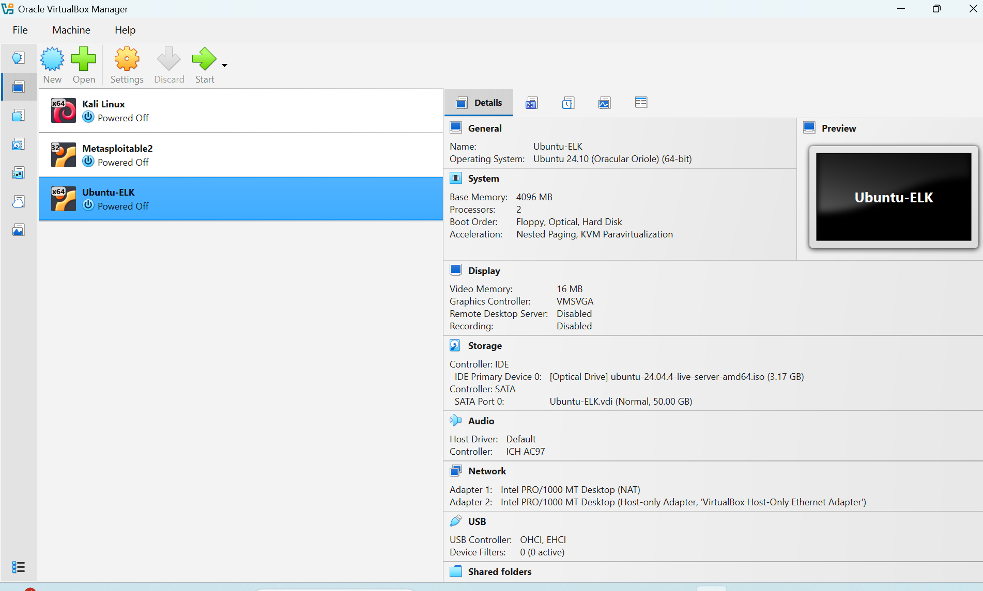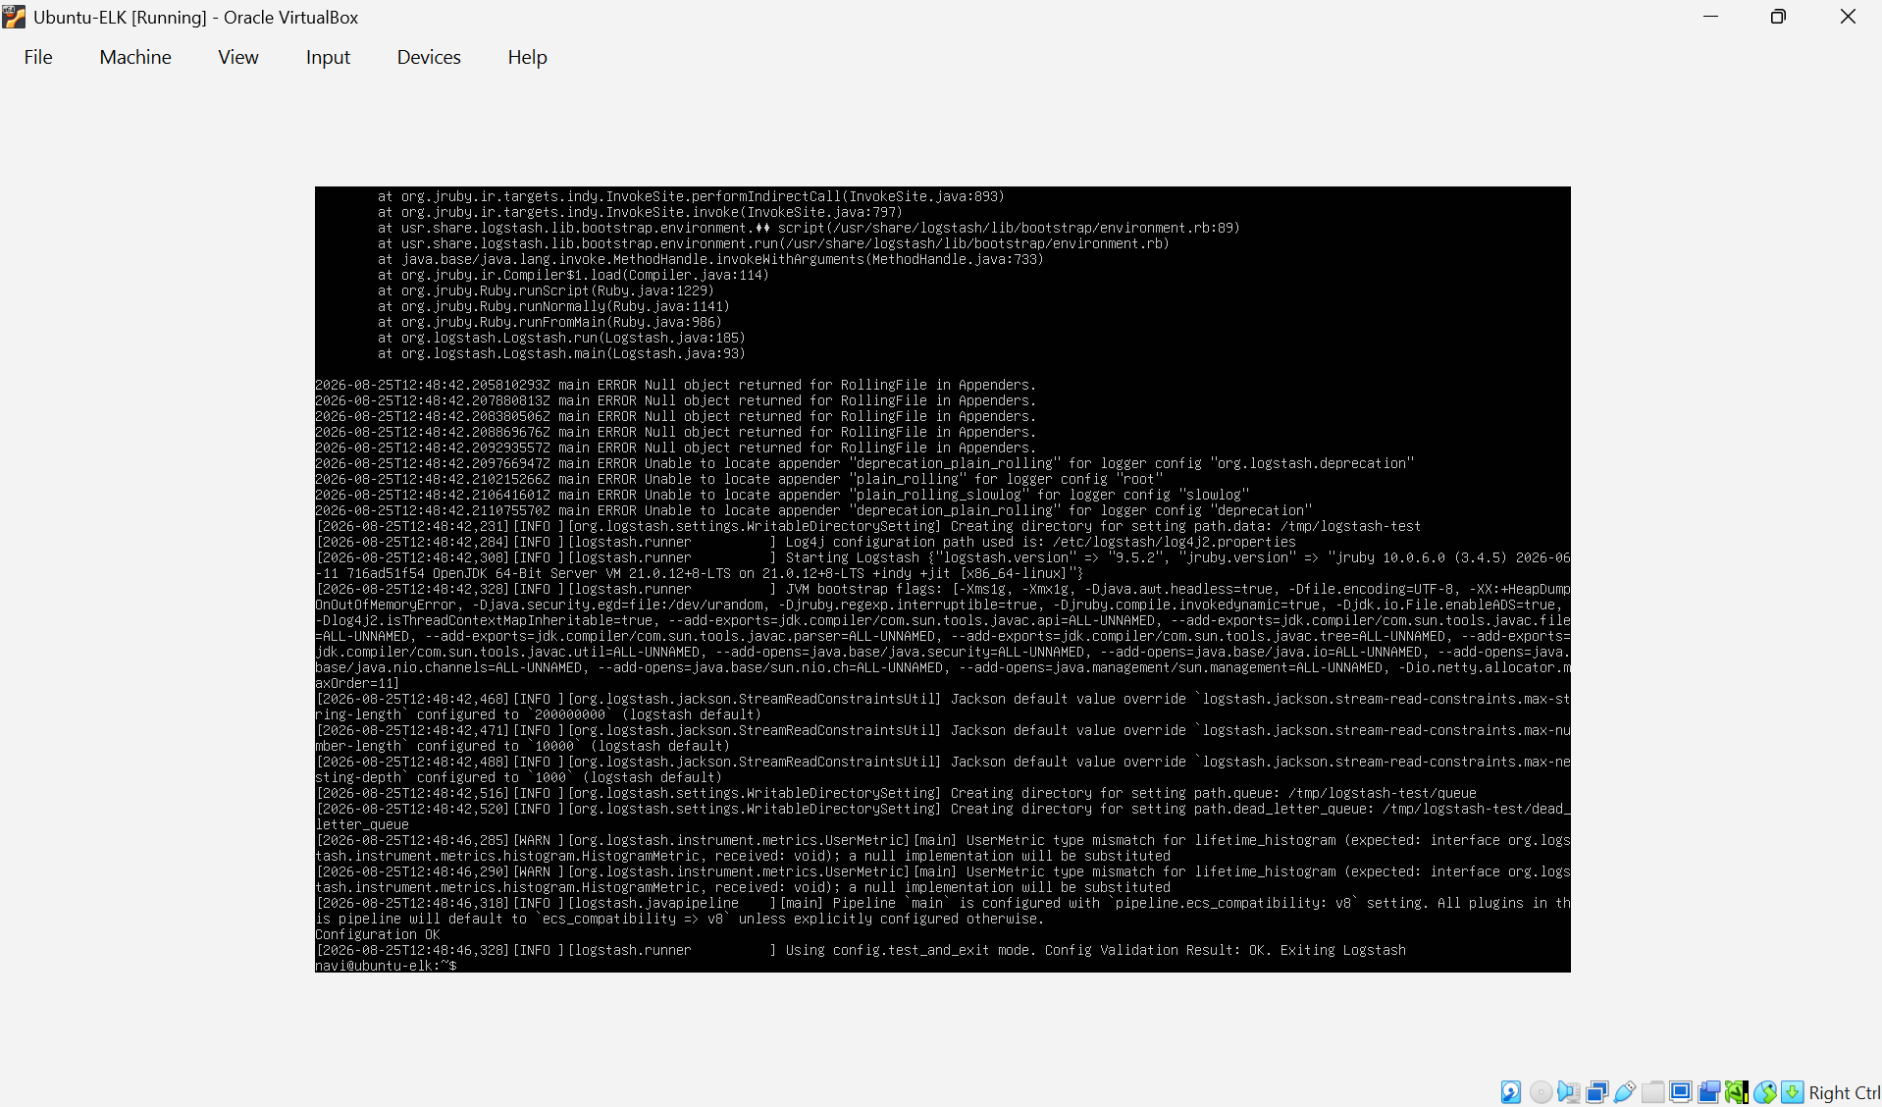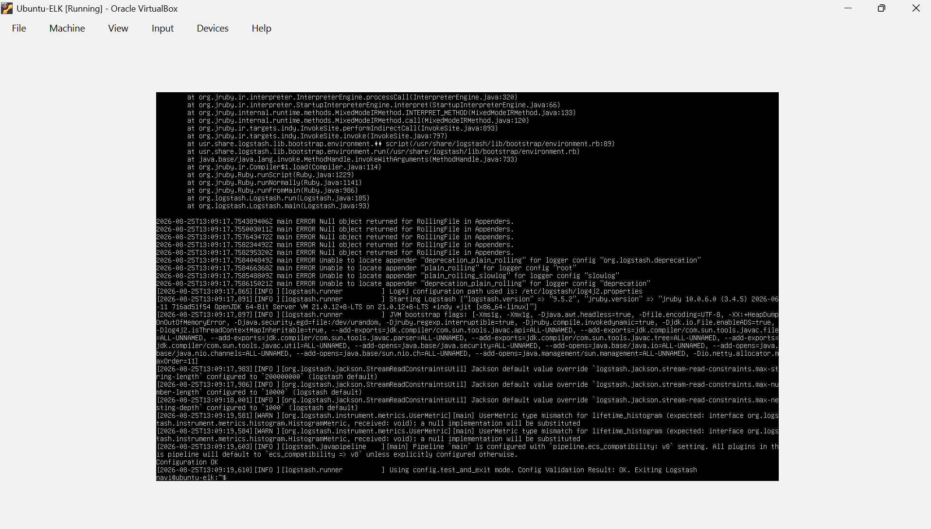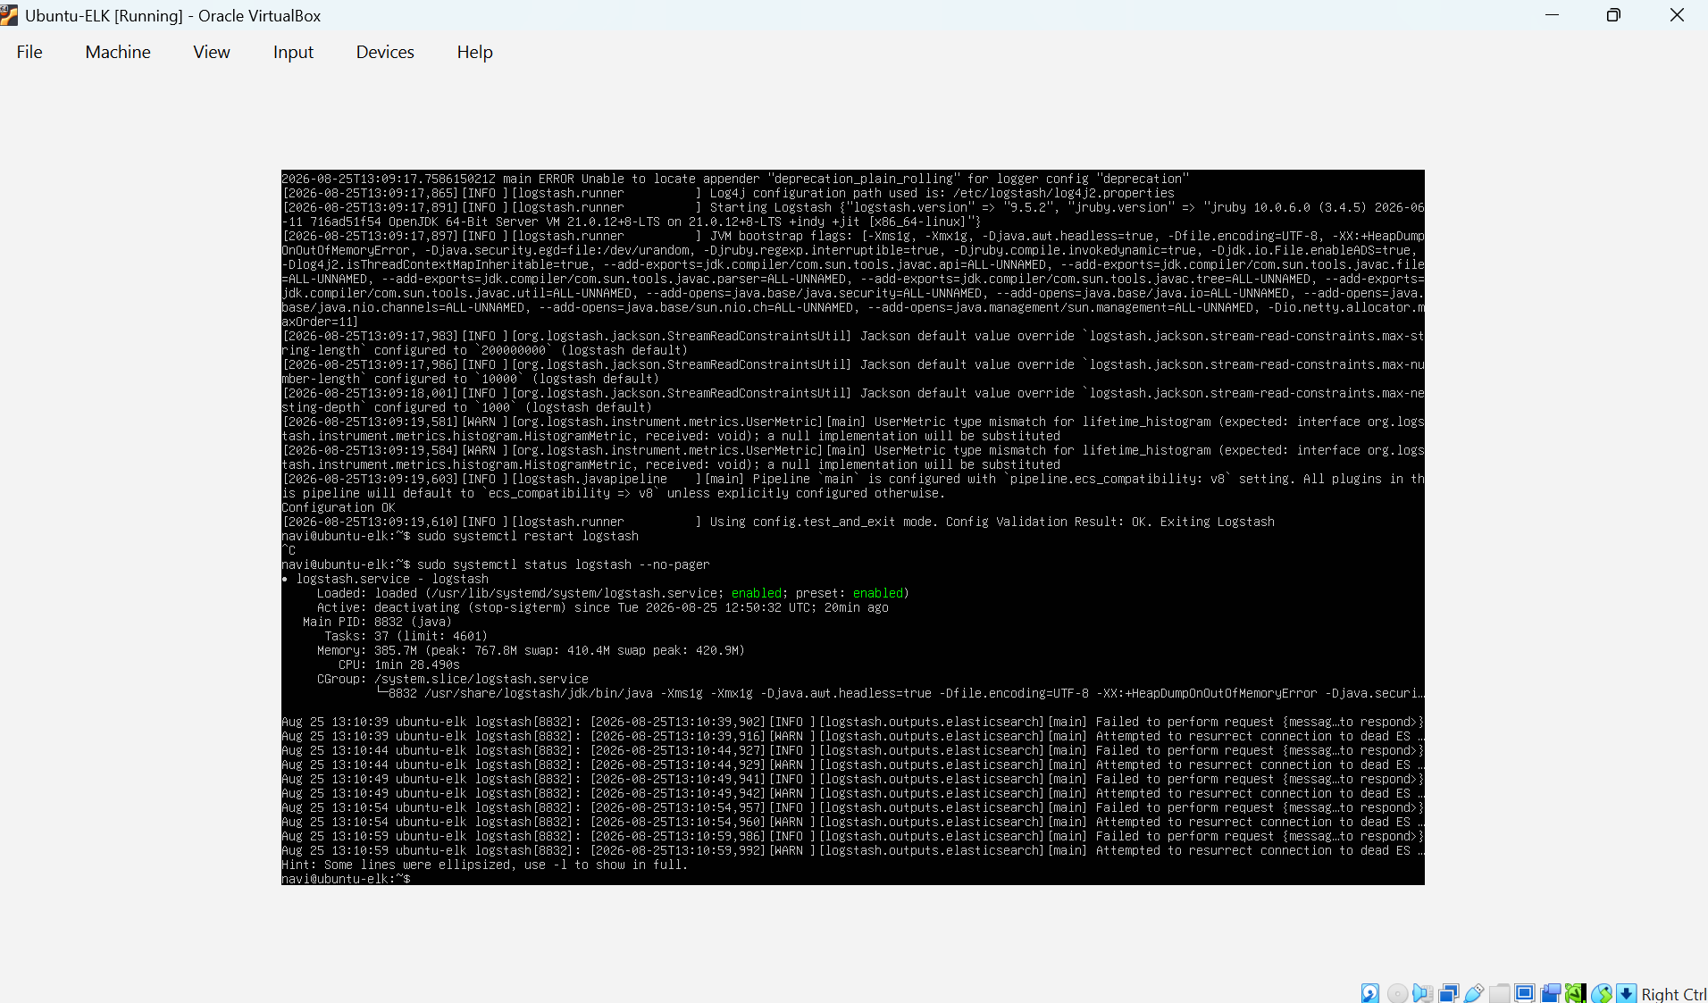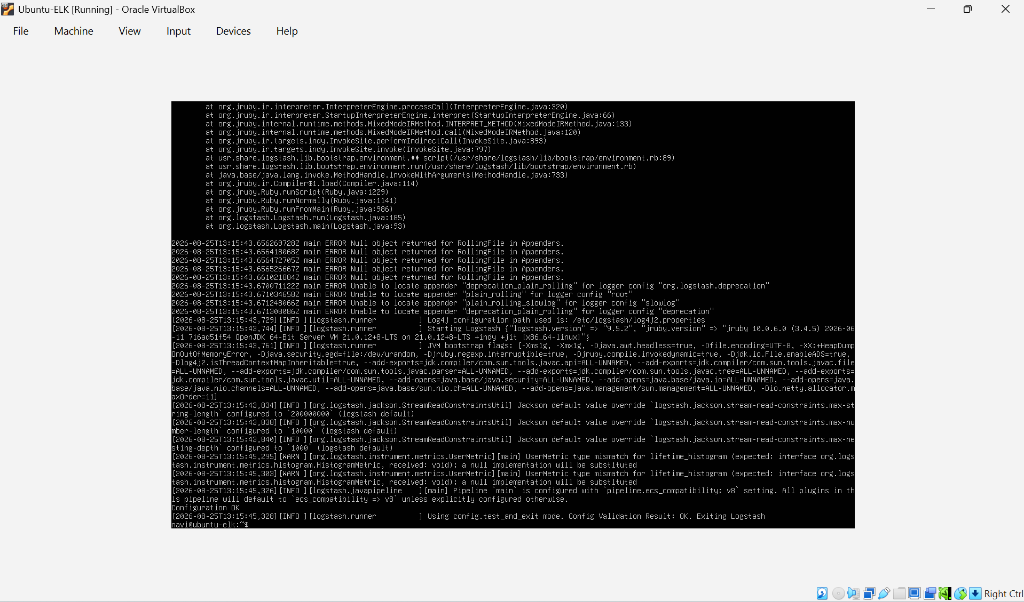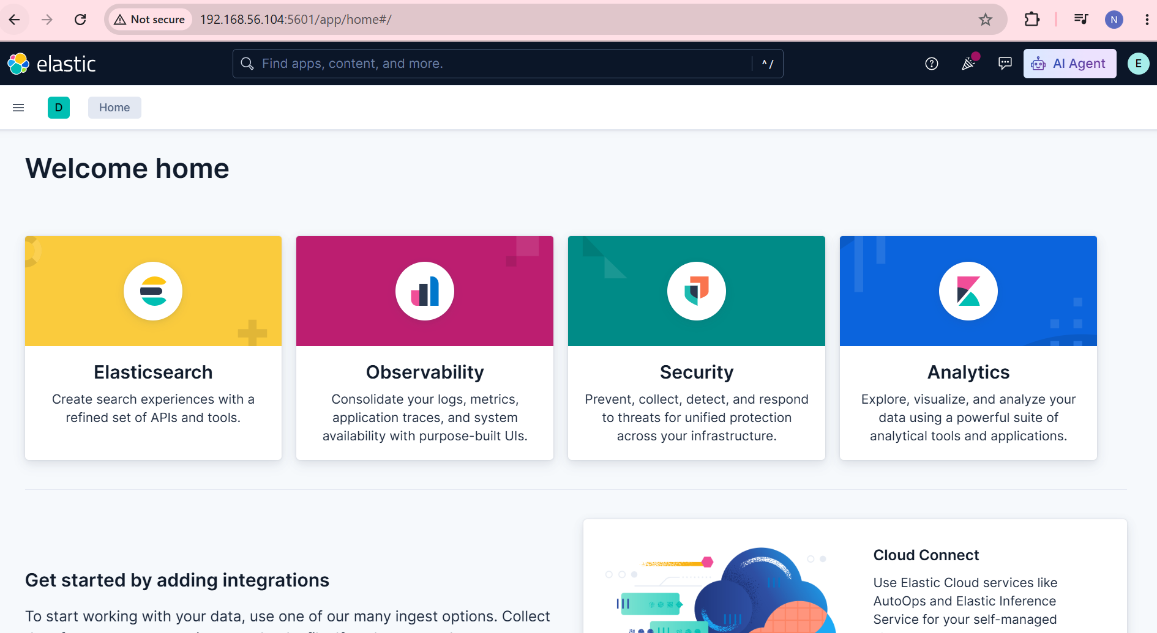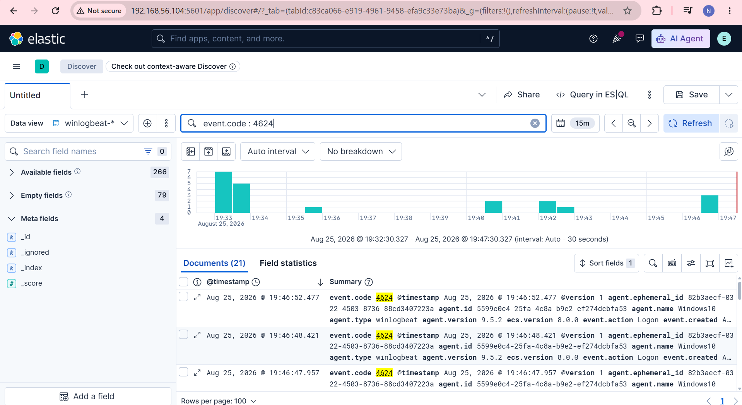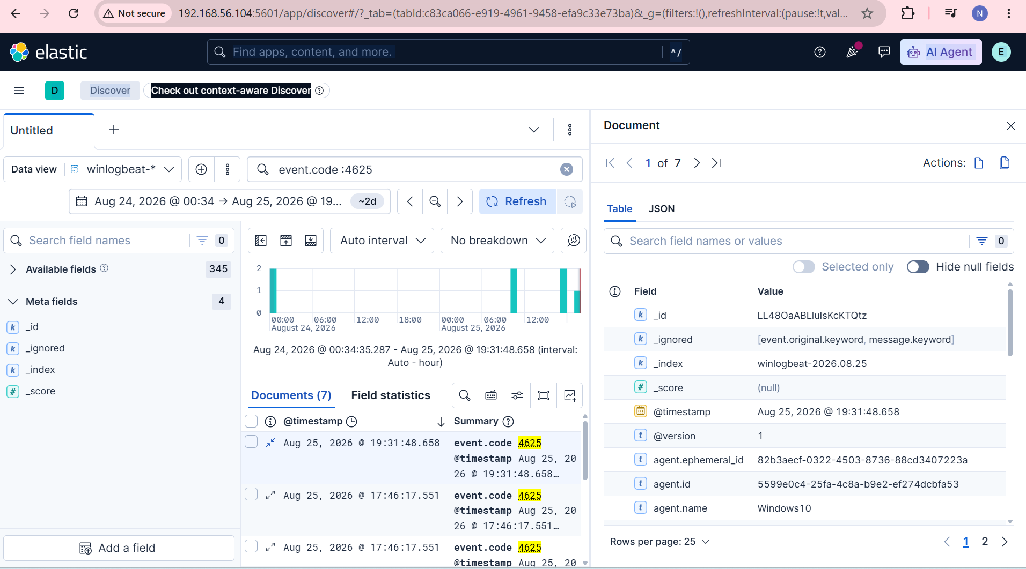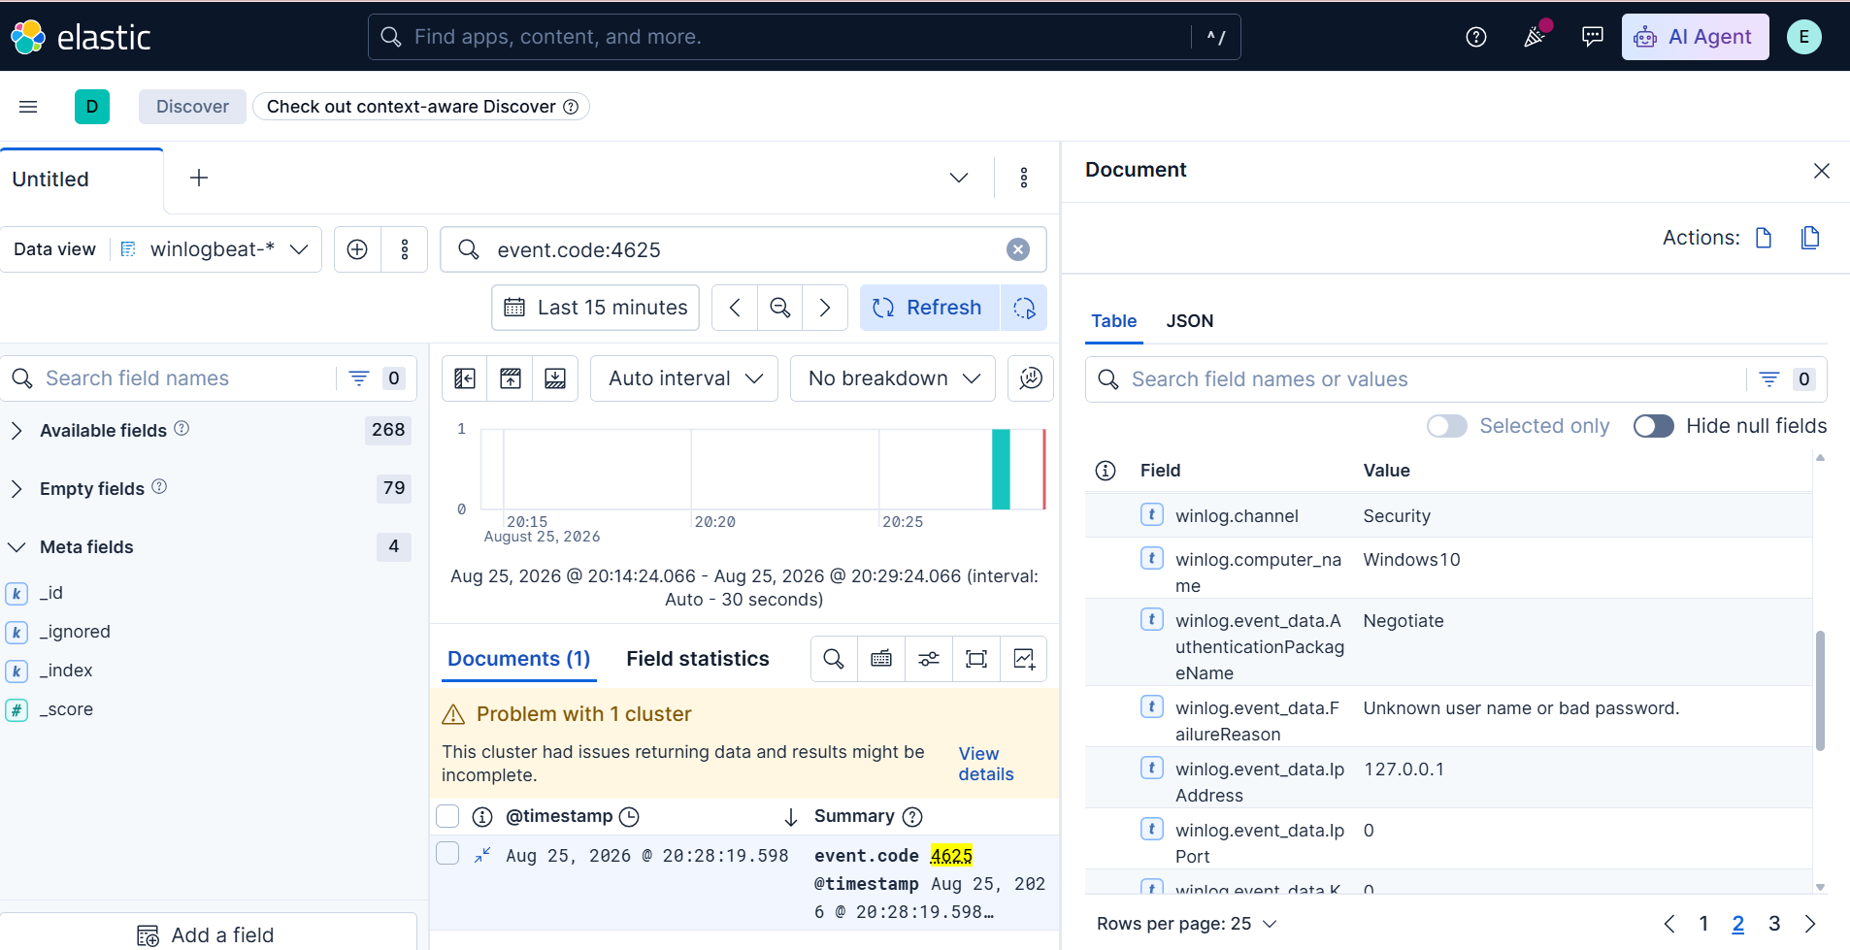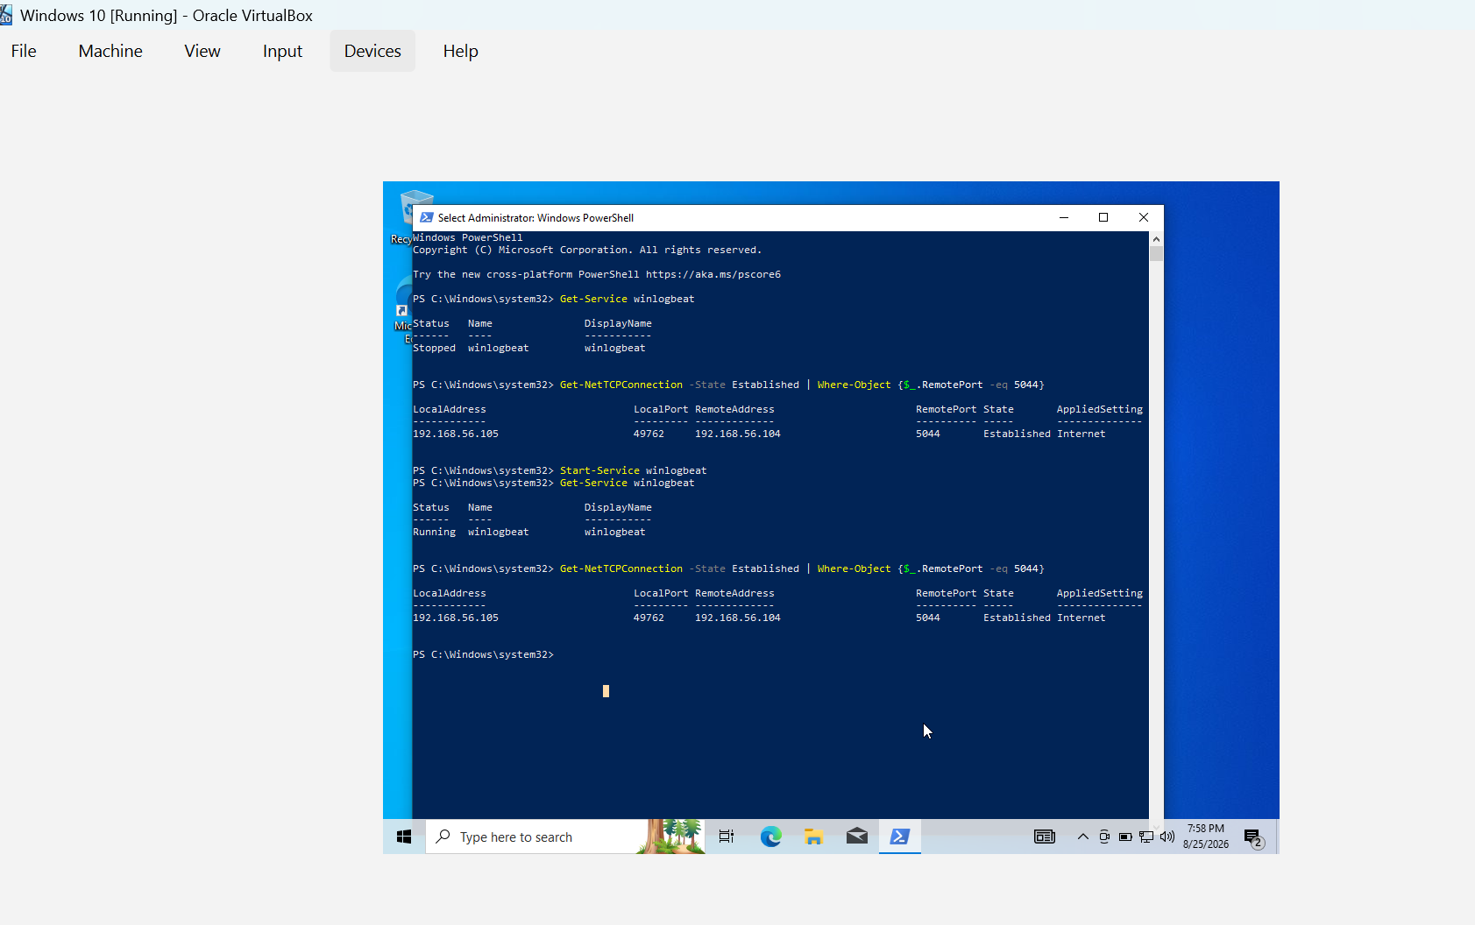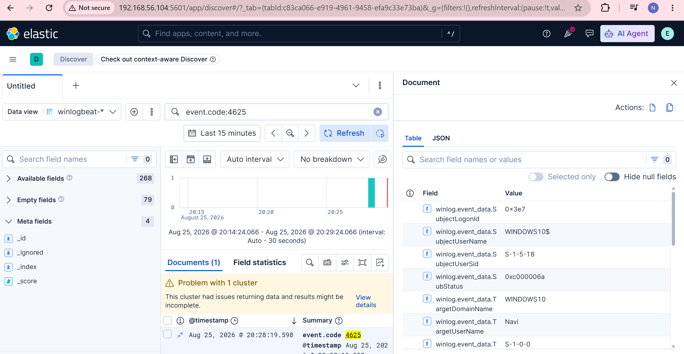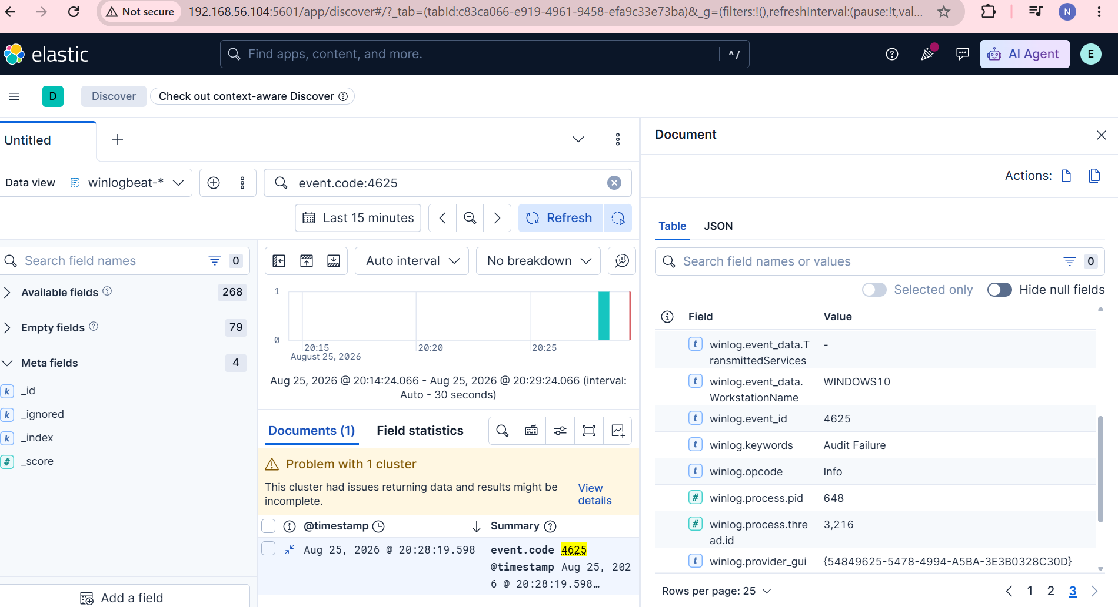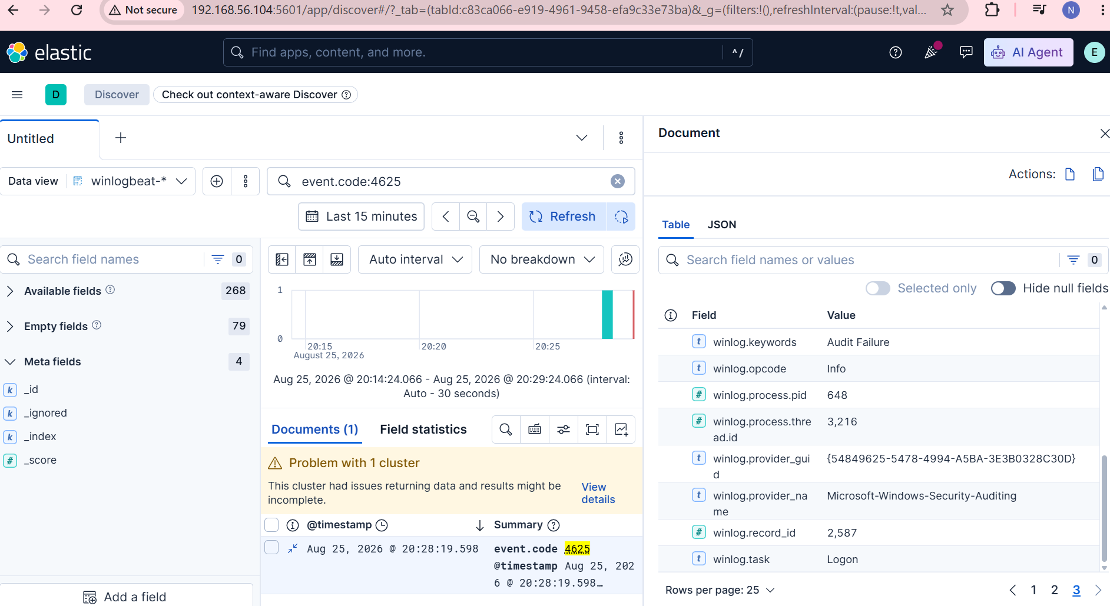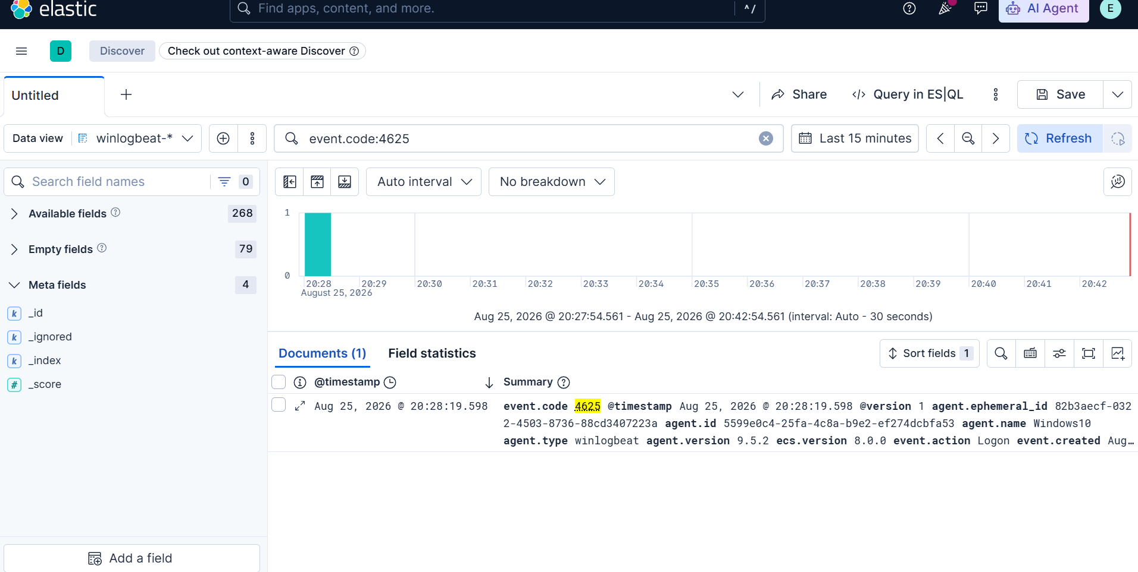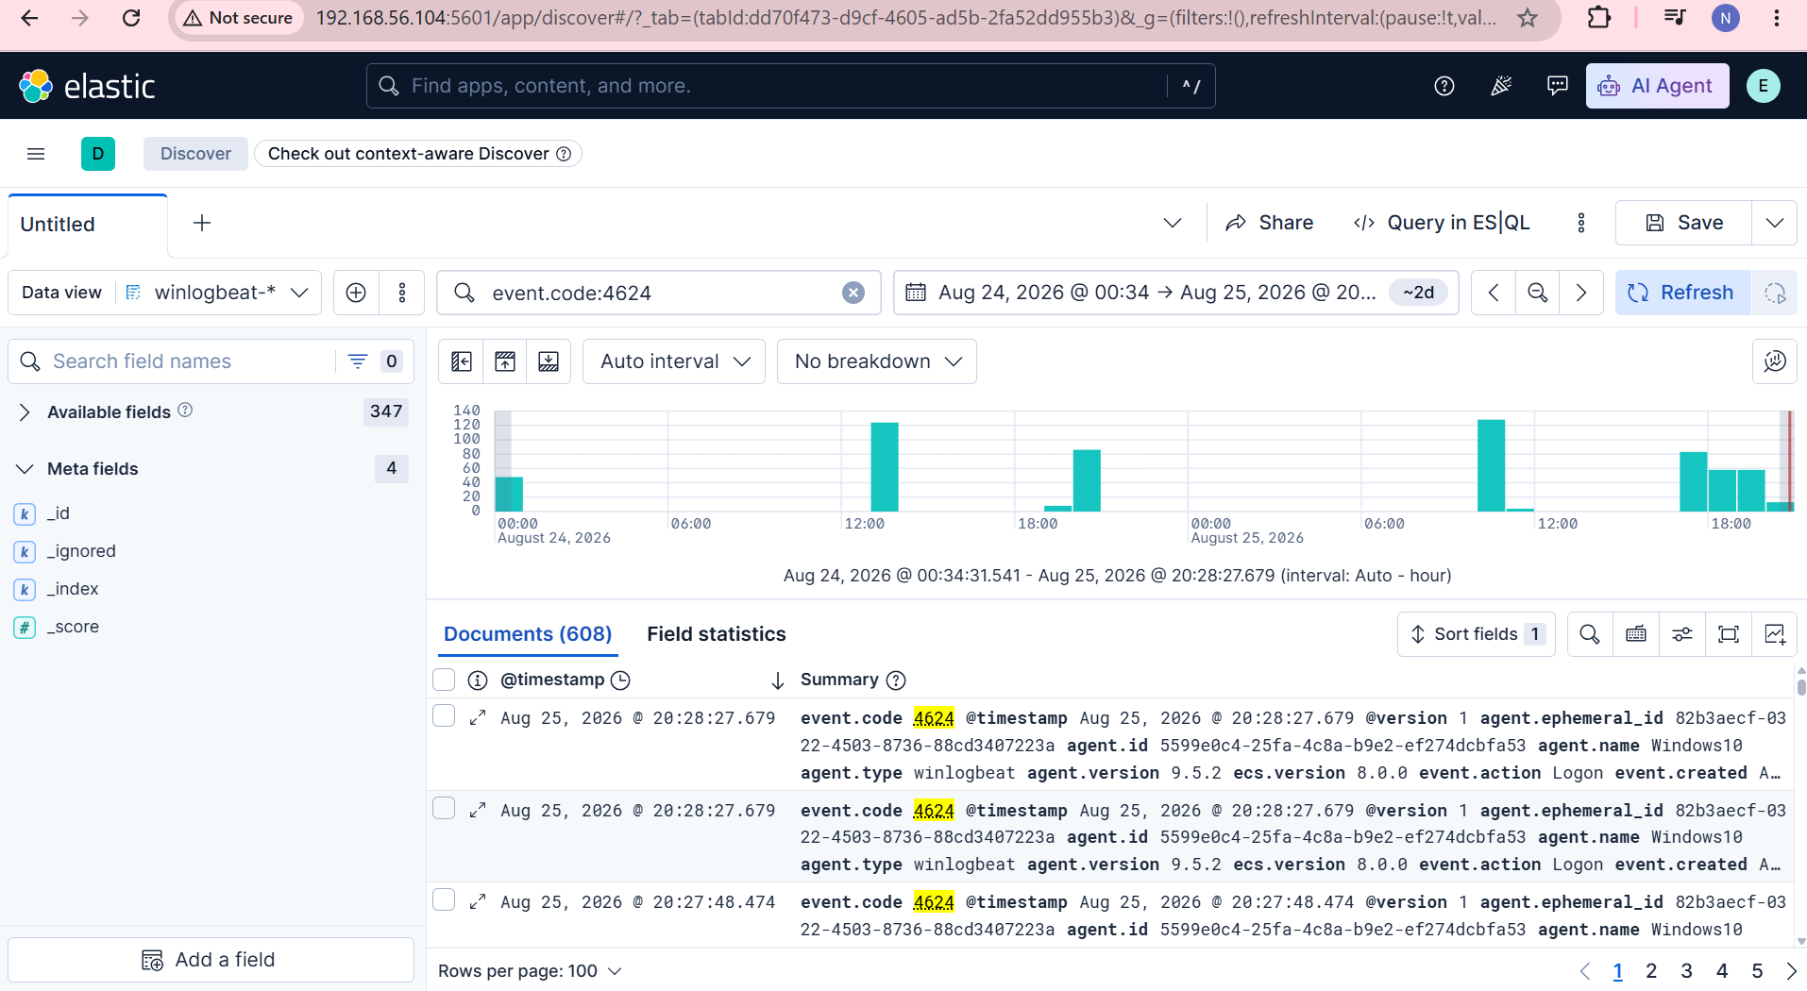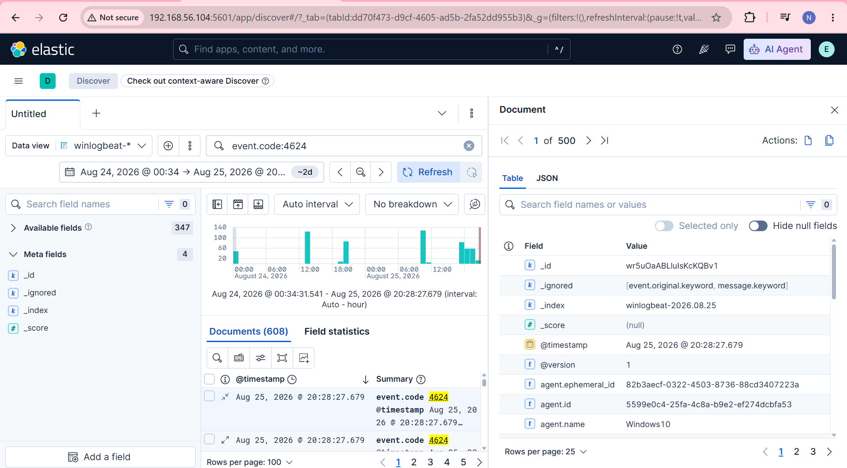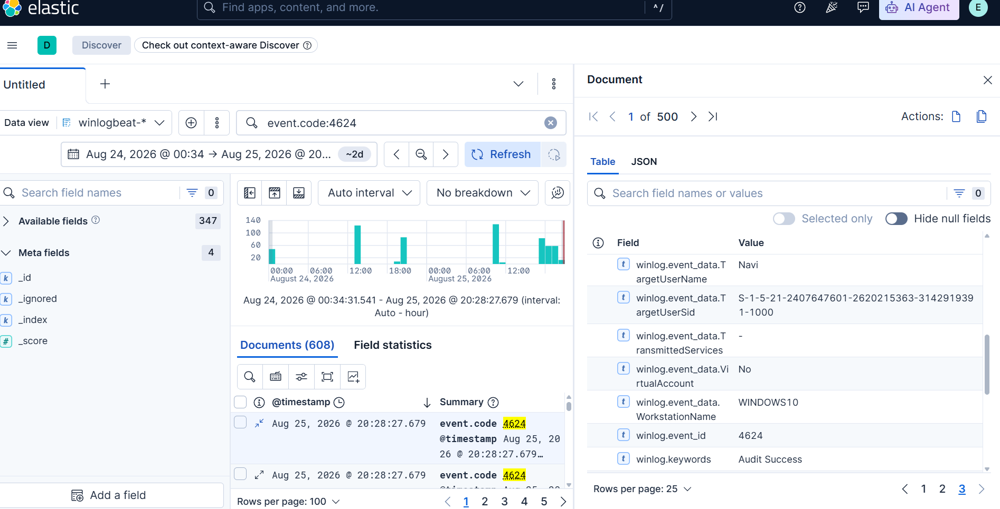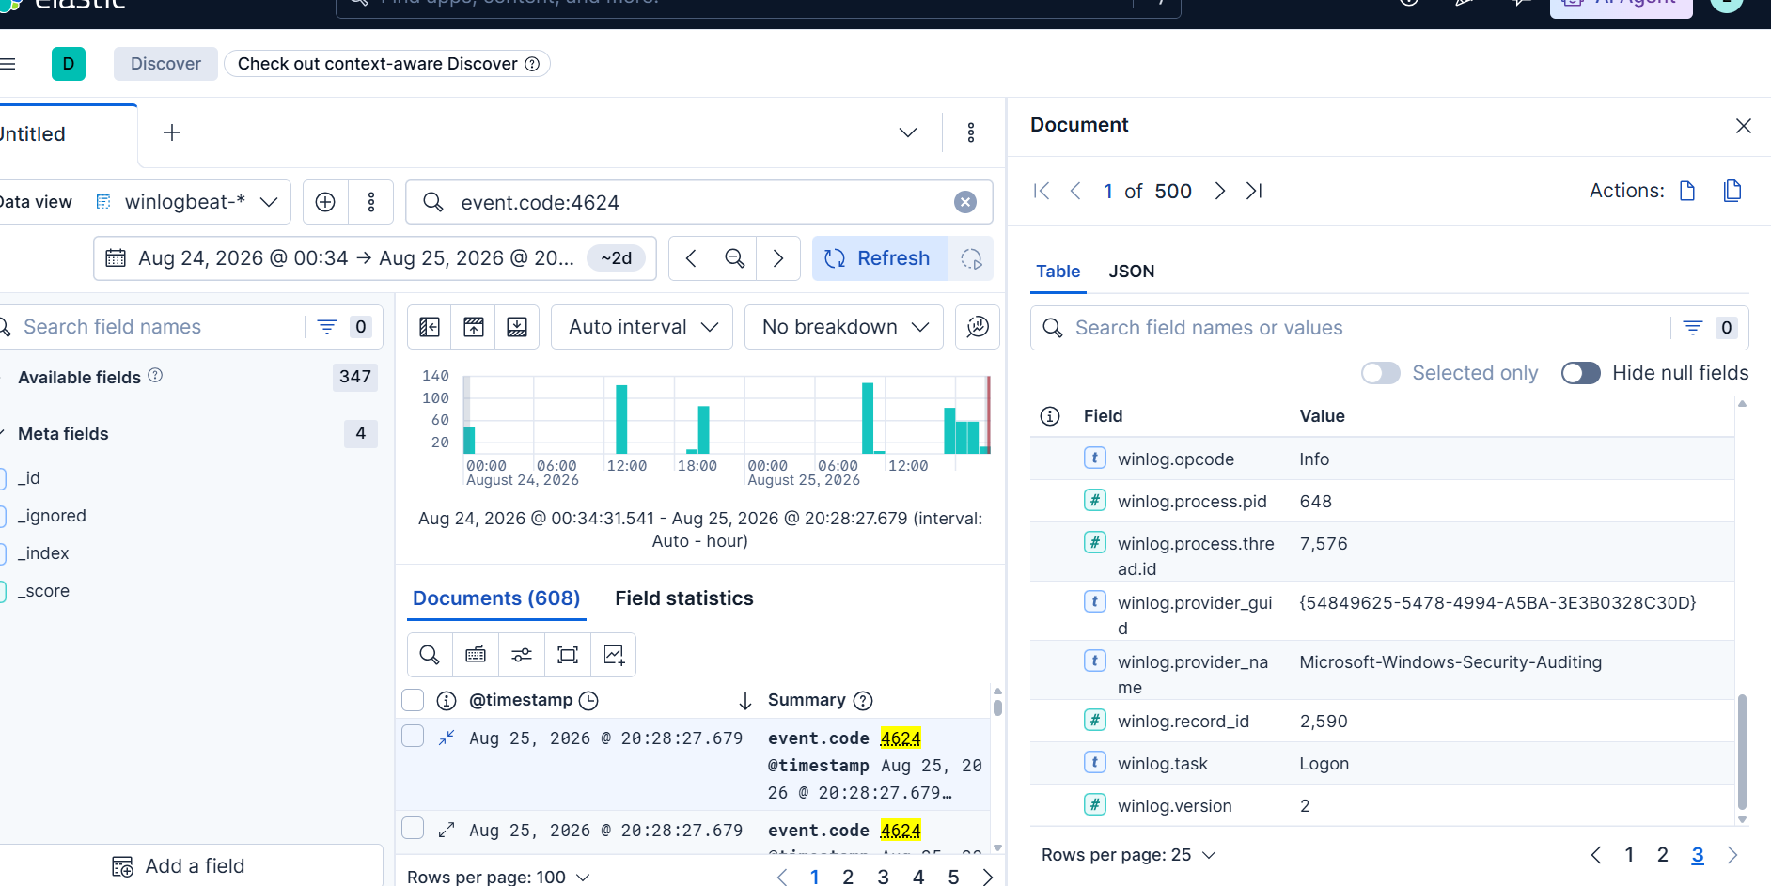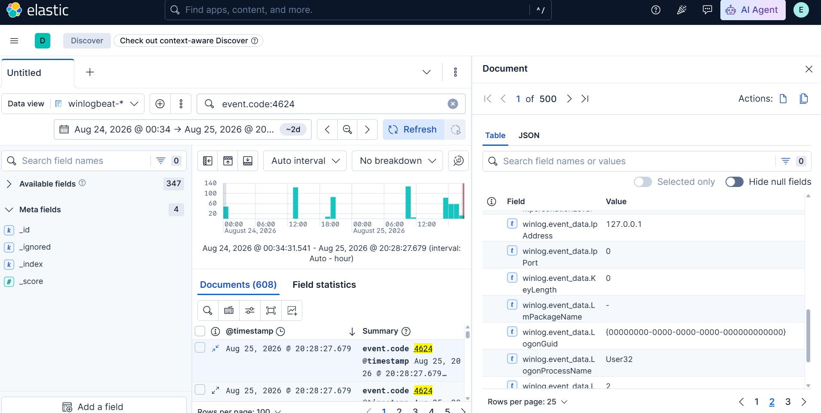

13. Conclusion
The project successfully demonstrates the concept of centralized log monitoring and threat detection using the ELK Stack. By using Elasticsearch, Logstash, and Kibana, security-related log data can be collected, processed, stored, searched, and analyzed from a centralized platform.
The project demonstrates the use of Winlogbeat for Windows log collection and the intended use of Filebeat for Linux authentication and system logs. Kibana provides an effective interface for viewing and analyzing collected events, while Kibana Query Language (KQL) allows specific security events to be identified quickly.
The implementation also demonstrates important cybersecurity use-cases such as Windows failed login detection, suspicious successful login monitoring, Linux SSH login monitoring, and File Integrity Monitoring. Events such as Event ID 4624 and Event ID 4625 provide useful information for analyzing successful and failed authentication attempts.
Overall, the project provides practical understanding of SIEM, centralized logging, log analysis, security monitoring, threat detection, dashboards, and alerting. It demonstrates how an ELK-based centralized monitoring system can support security analysts in identifying suspicious activities and investigating security events in a structured manner.

